

Department of Computer Science and Engineering

Course Code: CSE464

Course Title: Advance Database

Section: 02

Semester: Fall 24

**LAB-1 Assignment**

**Submitted to:**

**Khairum Islam**

Lecturer

Department of Computer Science and Engineering

East West University

**Submitted by:**

**Name:** B M Shahria Alam

**ID:** 2021-3-60-016

**Date of submission:** 2nd November, 2024.

EXERCISE 1:

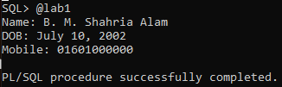

EXERCISE 2:

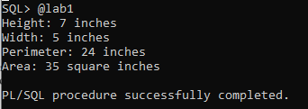

EXERCISE 3:

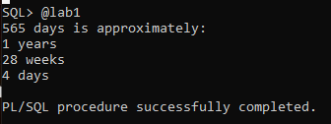

EXERCISE 4:

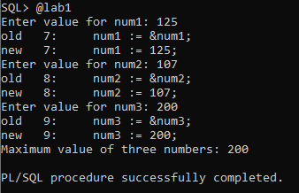

EXERCISE 5:

